**Assignment -3**

**Build CNN Model for Classification Of Flowers**

|  |  |
| --- | --- |
| Assignment submission | 12 October 2022 |
| Student Name | Raja Shelshita A |
| Student Roll Number | 951919CS078 |
| Maximum Marks | 2 Marks |

1. Download the dataset: Dataset

>from google.colab import drive

>drive.mount('/content/drive')

Mounted at /content/drive

>cd /content/drive/MyDrive

/content/drive/MyDrive

>!unzip Flowers-Dataset.zip

Archive: Flowers-Dataset.zip

inflating: flowers/daisy/100080576_f52e8ee070_n.jpg

inflating: flowers/daisy/10140303196_b88d3d6cec.jpg

inflating: flowers/daisy/10172379554_b296050f82_n.jpg

inflating: flowers/daisy/10172567486_2748826a8b.jpg

inflating: flowers/daisy/10172636503_21bededa75_n.jpg

inflating: flowers/daisy/102841525_bd6628ae3c.jpg

2. Image Augmentation

from tensorflow.keras.preprocessing.image import ImageDataGenerator

train_datagen=ImageDataGenerator(rescale=1./255,zoom_range=0.2,horizontal_flip=True,vertical_flip=False)

test_datagen=ImageDataGenerator(rescale=1./255)

3. Create Model

>X_train=train_datagen.flow_from_directory('/content/drive/MyDrive/Flowers-Dataset/flowers',target_size=(64,64),class_mode='categorical',batch_size=24)

Found 30 images belonging to 5 classes.

>X_test=train_datagen.flow_from_directory('/content/drive/MyDrive/Flowers-Dataset/flowers',target_size=(64,64),class_mode='categorical',batch_size=24)

Found 40 images belonging to 5 classes.

>X_train.class_indices

{'daisy': 0, 'dandelion': 1, 'rose': 2, 'sunflower': 3, 'tulip': 4}

4. Add Layers (Convolution,MaxPooling,Flatten,Dense-(Hidden Layers),Output)

from tensorflow.keras.models import Sequential

from tensorflow.keras.layers import Dense,Convolution2D,MaxPooling2D,Flatten

model=Sequential()

model.add(Convolution2D(32,(3,3),input_shape=(64,64,3),activation='relu'))

model.add(MaxPooling2D(pool_size=(2,2)))

model.add(Flatten())

model.summary()

Model: "sequential_1"

_________________________________________________________________

Layer (type) Output Shape Param #

=================================================================

conv2d (Conv2D) (None, 62, 62, 32) 896

max_pooling2d (MaxPooling2D (None, 31, 31, 32) 0

)

flatten (Flatten) (None, 30752) 0

=================================================================

Total params: 896

Trainable params: 896

Non-trainable params: 0

model.add(Dense(300,activation='relu'))

model.add(Dense(150,activation='relu'))

model.add(Dense(4,activation='softmax'))

5. Compile The Model

model.compile(loss='categorical_crossentropy',optimizer='adam',metrics=['accuracy'])

6. Fit The Model

model.fit_generator(X_train,steps_per_epoch=len(X_train),validation_data=X_test,validation_steps=len(X_test),epochs=10)

7. Save The Model

model.save('flowersss.h5')

8. Test The Model

import numpy as np

from tensorflow.keras.models import load_model

from tensorflow.keras.preprocessing import image

model=load_model('/content/drive/MyDrive/flowersss')

img=image.load_img("/content/drive/MyDrive/flowers/daisy/153210866_03cc9f2f36.jpg" )

img

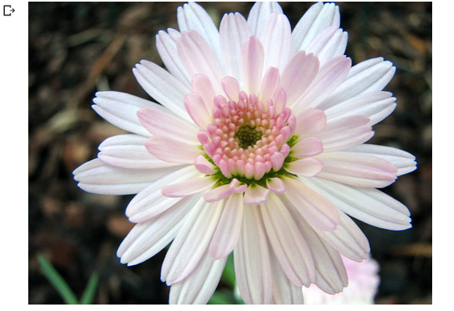

>img=image.load_img("/content/drive/MyDrive/flowers/daisy/153210866_03cc9f2f36.jpg",target_size=(64,64) )

img

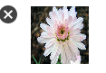

>X=image.img_to_array(img)

>X

array([[[13., 20., 13.], [14., 23., 18.], [20., 27., 20.], ..., [50., 41., 32.], [46., 37., 28.], [17., 19., 14.]], [[18., 20., 15.], [25., 31., 29.], [29., 31., 28.], ..., [46., 48., 34.], [50., 41., 32.], [ 3., 5., 4.]], [[14., 20., 16.], [17., 22., 16.], [18., 20., 17.], ..., [52., 50., 38.], [50., 47., 38.], [21., 23., 20.]], ..., [[21., 26., 20.], [40., 40., 32.], [34., 35., 30.], ..., [21., 28., 21.], [11., 15., 14.], [22., 21., 17.]], [[26., 31., 27.], [53., 53., 43.], [32., 37., 31.], ..., [28., 34., 24.], [21., 31., 22.], [50., 50., 38.]], [[34., 36., 31.], [43., 46., 35.], [24., 26., 21.], ..., [71., 65., 49.], [69., 63., 47.], [83., 76., 60.]]], dtype=float32)

>y=np.argmax(model.predict(X),axis=1)

>y

array([0])

>X_train.class_indices

{'daisy': 0, 'dandelion': 1, 'rose': 2, 'sunflower': 3, 'tulip': 4}

>index=['daisy', 'dandelion','rose', 'sunflower','tulip']

>index[y[0]]

'daisy'